BAU International University, Batumi

Statute of
School of Medicine and Health Sciences

Batumi
2026

Table of Contents
Chapter I. General Provisions 3
Article 1. Introduction 3
Article 2. Goals of the School of Medicine and Health Sciences 3
Article 3. The Structure of the School 4
Chapter II. Governing Bodies 5
Article 5. Composition of the School Council 5
Article 5. Procedures of the School Board 5
Article 6. Fucntions of the School Council 7
Artivle 7. Dean 8
Article 8. Learning process Department 9
Article 9. Head of the educational program 10
Article 10. Functions of the head of the educational program 10
Article 11. Training course/block coordinator 11
Article 12. Manager of the laboratory department 11
Article 13. Functions of the laboratory department manager 11
Article 14. Tutor 12
Article 15. Academic and invited staff 12
Article 16. Student 13
Article 17. Final Provisions 13

Chapter I. General Provisions

Article 1. Introduction
1. The present Statute defines the structure, objectives, tasks and other issues related to the functioning of the School of Medicine and Health Sciences (hereinafter referred to as the "School") of "Bau International University, Batumi" LLC (hereinafter referred to as the "University").
2. The School of Medicine and Health Sciences is the main educational, research and administrative unit of the University, which implements higher educational programs in the field of healthcare and awards graduates with the appropriate academic degree (qualification) in accordance with the specialties of the programs implemented within the School.
3. Higher educational programs in the School are conducted in English.
4. The School has a seal for the implementation of its activities.
5. During the exercise of authority, the school is guided by the Charter of the University, by-laws, acts issued by the Rector (relating to the school's activities) and is responsible for the performance of the functions defined by this Statute. Exercising its authority, the school is also guided by the legislative and by-law normative acts in the field of higher education.

Article 2. Goals of the School of Medicine and Health Sciences
1. The main goal of the school is to educate competitive, highly qualified personnel focused on the local and international employment market and to promote their integration in the world educational/scientific space in the direction of health care.
2. The tasks of the school are:
a) Continuous development and refinement of the educational programs;
b) Providing the opportunity to receive education based on the latest knowledge and experience;
c) Development of joint educational programs, scientific-research projects and other academic or scientific activities with Georgian and foreign universities and promotion of implementation of international cooperation projects;
d) Promotion of scientific research, introduction of new knowledge and integration of research into teaching;
e) Development of international scientific cooperation;
f) Creating an adequate simulation environment and providing a clinical environment for the development of appropriate clinical skills for the student;
g) Creating a student-oriented academic environment;
h) Taking care of professional development of academic staff;
i) Promotion of academic freedom;
j) Promoting the formation of professionalism among students;
k) Development of the educational environment of the school in accordance with the strategy of the University;
m) Promotion of community development through involvement in various social activities

Article 3. The Structure of the School
1. The School consists of the school Council, the Dean, Vice-dean, Learning Process Management Department, Director(s) of the Educational Program(s), Clinical Skills and OSCE Center Manager(s), Laboratory Manager(s), as well as academic and invited staff who lead the educational process and scientific-research activity in educational directions carried out by the School.

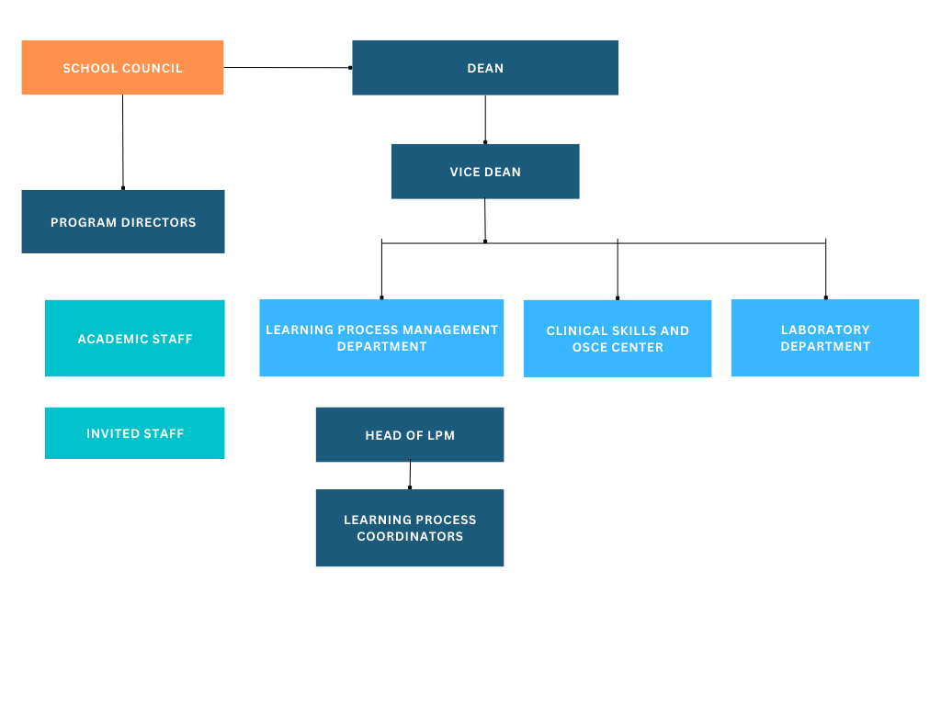
2. In addition to the bodies defined by the school structure, various commissions and working groups can be created for the purpose of designing and developing the curriculum, administering the implementation of the block/course, as well as studying and/or other issues related to the school's activities.
3. The governing bodies of the School are School Council and the Dean.
4. The School is accountable to the Vice Rector for Academic Affairs and the Academic Council of the University in its academic and scientific and to the Vice Rector for Administrative Affairs in its organizational and administrative performance.

Chapter II. Governing Bodies
Article 4. Governing Bodies of the School
1. Governing bodies of the School Are
a). Dean of the School
b). School Council
1. The School Council is a collegial body within the school that determines the main directions of the school's activities.
5. The administrative activities of the school are managed by the Dean.

Article 5. Composition of the School Council
1. The school Council includes:
a) Dean of the School;
b) All affiliated professors of the school (professor, associate professor, assistant professor) after being elected in accordance with the law, the professor automatically becomes a member of the School Council, if he does not refuse to be a member of the school council on his own initiative, or his membership of the school council is not terminated in accordance with this Statute. );
c) student representatives appointed by the student self-government the amount of which cannot be less than ¼ of the professors of the Council;
2. The grounds for suspending the authority of a School Council member are:
a) in the case of academic staff - The course of the disciplinary production process.
to academic staff
b) in the case of a student - suspension of status or disciplinary proceedings against him
3. The grounds for terminating the authority of a school council member are:
a) in the case of academic staff - leaving the academic position, dismissal from the academic position or expiration of the term of election to the position, as well as a personal statement about the request to terminate the membership of the school council.
b) In the case of a student - termination of status or personal statement on the request for termination of membership of the school council.
c) In the case of all members - the Council's decision regarding the termination of a Council member's authority, disciplinary misconduct, gross violation of the rules of ethics, as well as in the event that he/she has missed more than half of the semester sessions of the Council due to a dishonest reason.

Article 5. Procedures of the School Council
1. The School Council conducts its activities in accordance with the present regulations and the internal regulatory acts of the educational university
2. The meeting of the school council is presided over by the dean of the school, and the minutes are drawn up by the secretary of the meeting chosen by the chairman.
3. School board meetings are held as needed, at least once every two months. The chairman has the right to call the meeting independently or by the members of the school Councilat the request of the majority.
4. About the holding of the school council, the members of the council are notified at least two calendar days in advance, by e-mail or through electronic management systems, or immediately as needed. before the school session(except for the immediately held meeting) one calendar day before the school council members will be provided with the agenda and drafts of the issues to be discussed.
5. The school council makes a decision based on voting, with a majority of the votes present. In case of a split vote, the chairman's vote is decisive.
6. The decision is formed by a resolution signed by the chairman of the council - the dean and the secretary of the meeting chosen by the chairman of the council.
7. School board members confirm their attendance by signing the attendance sheet, orIt is confirmed by the council's video recording
8. The school board is authorized if the majority of the full composition is present.
9. The meeting of the school council is held openly.
By decision, of the majority of the present members of the school board it is possible to close the session in whole or in part depending on the discussed issue.
10. Depending on the need, it is possible to hold the board meeting remotely, using electronic means of communication. The openness of the meeting held remotely is ensured by recording the progress of the meeting. In case of long-distance communication, the council member is obliged
to convince the Council to personally participate in the session with appropriate evidence, as well as,
To follow the distance communication ethics established by the educational university
norms.
11. Voting on the school council is conducted openly. By decision of the majority of the present members of the school board, a secret ballot may be held. During the voting, the council member has no right to abstain from voting. The decisions of the school council are made by the majority of the votes of those present. In case of a split vote, the chairman's vote is decisive. The decision to terminate the authority of a member of the Council is made by the majority of 2/3 of the members present. The member of the Council whose authority is being considered does not participate in the voting.
12. It is possible to invite persons who are related to the issue of the agenda of the meeting to participate in the meeting of the school council.
13. All members of the council must be invited to the school meeting. The member of the council is obliged
To appear at the appointed time, in case of non-appearance, the reason should be given in advance
to inform the chairman of the school board. In case of absence, the absence of the Council meeting by the member of the Council is considered dishonorable.
14. A member of the school board may attend the meeting through electronic communication, in such a way that direct visual contact of the board member is ensured and his voice can be identified.
15. The meeting of the school board is opened by the chairman of the board, who presents the agenda to the board
order. It is allowed to make changes to the agenda directly at the meeting, if the situation requires it.
16. The process of the school council is reflected in the minutes. The protocol should indicate:
a) date and place of the session;
b) identity of academic persons and invited persons present at the session;
c) agenda;
d) voting results;
e) the decision made.
17. The written material presented by the speakers (if any) will be attached to the minutes of the meeting. In the case of a session held remotely, the minutes
The corresponding video recording is attached.

Article 6. Functions of the School Council
1. School Council:
a) Ensures the development of the school structure and regulations on the proposal of the dean;
b) Determines the coefficients and barriers and the number of students admitted to the educational program of the school and submitting it to the Academic Council for approval;
c) Ensures the initial review of the new educational program presented by the initiator of the program, in case of a positive conclusion of the quality assurance service, submists program draft to the Academic Council for approval;
d) Ensures the approval of minor changes in the current program (updating literature and topics in the syllabus, updating evaluation methods, etc.). Minor changes are changes that do not change the learning outcomes of the educational program.
e) Develops the directions of the main educational, scientific-research activities of the
f) Approval study schedule;
g) Provides review and approval of individual curriculum;
h) Ensures the approval of the schedule and composition of collegial mutual attendance at lectures and practical classes;
i) Provides discussion of issues related to the educational process
j) Initiates the determination of personnel changes in the school (if necessary), the calculation of the number of academic and guest personnel vacancies (taking into account the target indicators) and the determination of competition directions, and addresses the Rector with a proposal to announce the competition;
k) in accordance with the action plan of the university, ensures the development of the action plan of the school and the submission of the budget of the action plan to the Academic Council;
l) Ensures the formation of permanent and temporary commissions of the school, if necessary, on the recommendation of the dean;
n) Ensures discussion of various current issues facing the school.
o) Considers the issue of announcing a reprimand to a member of the Council, in case of repeatedly missing the session of the Council without an honorable reason, makes a decision regarding the termination of the authority of the member of the Council, in accordance with the procedure established by this Statute.
p) Ensures the development of the procedure for conducting exams and submits it to the Academic Council for approval;
2. The school Council is authorized to discuss and express its opinion on a matter that is not included in the list of functions defined by this article, but, depending on its content, the involvement and feedback of the academic staff and students of the university is required.
In the mentioned case, the person responsible for initiating or approving the relevant issue applies to the Dean of the School with a petition to prepare the issue for discussion at the School Council and participates in the discussion as an invited person.
3. The issues of the session are prepared by the chairman of the school council, however, if necessary, with the approval of the chairman, the issue can be prepared and brought to the session by the other member of the Council.

Article 7. Dean
1. The school is managed by Dean, who is the head of the school's administrative, academic and scientific activities.
2. Dean of the school:
a) Provides leadership of the school board, determines the agenda and approves on issues to be discussed;
b) Ensures effective management of educational and scientific activities of the school;
c) Ensures the development and presentation of drafts of the school's strategic/action plan and regulations at the meeting of the School Council;
d) Represents school in academic and scientific activities.
e) Is involved in the selection of teaching personnel together with the program director(s) and human resources service;
f) Negotiates with national and international educational institutions, clinical providers and other stakeholders to promote, support and enhance activities of the School.
g) Participates in the evaluation of the administrative and academic staff of the school, according to the rules established by the University;
h) Coordinates the work of school units, convenes them for the semester reports;
i) Elaborates and presents working plan and report of the School;
j) Within the scope of his/her competence, determines the professional development needs of academic and guest personnel, promotes the implementation of professional development processes of personnel by facilitating the human resources service.
k) provides activities for students' professional development (short-term clinical practices, summer/summer schools);
l) ensures the expansion of the partnership network with foreign educational/research institutions within the framework of the internationalization plan of the school's educational programs, supported by the international relations service;
m) Supervises the implementation of decisions of governing bodies of the University;
n) Represents the school with structural units of the University,
o) Ensures response to discipline violations within the school in the manner established by the legal acts of the university;
p) The reasoned answer given to the student or teacher within the authority of the school is no longer subject to appeal;
q) ensures inclusion in the activity process of the educational university and participates in the development/review of internal regulatory documents;
r) provides information about the current activities of the school for the relevant structural units of the University;
s) Signs the documents issued by the School – Diploma, Diploma Supplement, Academic Transcript, resolution of the School Council.
t) Exercises other powers granted to him by the internal regulatory acts of the educational university and the legislation of Georgia.

Article 8. Vice Dean
1. Vice-Dean of the School supports day-to-day administration of the school operations, ensuring effective management of the educational unit, supervises the work of Academic Department and performs Dean’s functions, if necessary.
2. Vice-Dean is accountable to the Dean of the School.
3. Key functions of the Vice Dean are:
a) Supervises administrative, academic and scientific activities of the School.
a) ensures the dean's assistance in effectively managing the administrative, educational and scientific process of the school;

b) Elaborates academic loading draft
c) Monitors fulfillment of the academic, scientific and office loading by the Faculty of the School.
d) Ensures consideration and response to individual statements of students related to the educational process within the scope of competence;
e) Provides analysis of rating and academic performance of the students.
Ensures the monitoring of operation of electronic learning management system
Supervises process of academic registration
Supervises the process of graduation and confirms on graduation certificate
Supervises preparation of Diploma supplement and other documents, provided by the School.
Provides other duties, if assigned by the Dean

Article 8. Academic Department
1. Administration of the educational process in the School and communication with students and faculty are managed by the Academic Department.
2. Academic Department consists of its head, who is accountable to the Vice-Dean of the University, and Academic Managers – assigned to a specific student cohort, which are accountable to Head of the Academic Department.
3. Functions of Head of Academic Department are as follows:
a) Supervises administrative activities of Academic Managers, divides tasks and responsibilities based on school needs and sizes of student cohort.
b) Ensures the involvement of Academic Department in effectively managing the administrative, and educational processes of the school;
c) Ensures the compilation of schedules and uploading them to the electronic management system;
d) Ensures the monitoring of the performance of the teaching process in accordance with the schedule;
e) ensures the preparation of the workload for the academic and administrative staff in agreement with the Program Director;
f) conducts negotiations with partner healthcare providers and assigns students to clinical rotations and clinical practice;
g) ensures the transfer of students to clinical bases;
h) Ensures the monitoring of the performance of the clinical practice process in accordance with the schedule;

3. Functions of Academic Managers are as follows:
c) ensures the monitoring of the performance of the training process in accordance with the training schedule;
d) ensures registration of missed hours and confirmation in the electronic system;
and the electronic delivery of this workload to the staff
- advising students during registration of study courses;
- f) provides assistance to students in the process of academic registration;
- g) ensures timely monitoring of the results of academic performance by teachers in the electronic system;
- e) provides the syllabus on the electronic management platform by the teachers
- monitoring of timely uploading of issues and training materials;
- g) ensures the preparation of the official version of the student evaluation card;
- h) Supervises the preparation of diploma annexes (together with the quality assurance service);
- i) provides information (study card, academic performance/academic registration) for students;
- j) ensures the delivery of syllabi and information related to the educational process (curriculum, workload, subject matters, etc.) for teachers;

a) advising and supporting students in planning the educational process and
to improve academic achievement;
b) about study courses, teaching and assessment methods of students
consulting;
c) monitoring the academic performance of students, collecting relevant information
and delivery to students and the dean's office;
d) Within the scope of authority, students' rights and legal interests
Facilitating safeguarding, uncovering problematic issues and to the Faculty Council
submission;
e) in university academic events and external educational-scientific curriculum
promotion of student involvement in activities;
f) assistance and support for students in other university needs;
g) Management of the student's portfolio (except for the clinical part), namely students
Scientific and educational curriculum of external activities of electronic management
Monitoring of portfolio placement on the platform and by students
Filling in the semester self-assessment and student evaluation by teachers
performance monitoring and summative feedback for the student;
g) preparing the semester report for the dean and presenting it to the school board;

7. The academic manager is accountable to the Head of the academic department.

Article 9. Program Director
1. The educational program is led by the head of the program, who is a specialist in a specific field and has a proper vision of the challenges of the academic/scientific or professional field of the field.
2. The head of the program is responsible for the quality of the program and compliance with accreditation requirements;
3. The head of the program is responsible to the Dean and the school Council;
4. It is permissible for the program to be led by two heads (no more than two) depending on the volume, specificity, academic and professional aspects of the program, or one person to lead two educational programs (no more than two).

Article 10. Functions of the head of the educational program
1. Head of the educational program:
a) Presents the basic concept of the program to the school board and in case of approval
Leads the curriculum team, with whom he develops the program, curriculum, learning outcomes and syllabi;
b) prepares the program for accreditation;
c) ensures the development of program resources (intellectual, material and human - together with the human resources service), participation in the search and evaluation of resources;
d) leads the content development of the program - takes responsibility for the content of the program concept, content of the program and training courses, teaching and evaluation methodology, and other documents provided for by the university's "Educational Programs Development and Implementation Rules";
e) prepares an outline of the academic and guest personnel involved in the program and submits it to the dean;
f) ensures the monitoring of the implementation of the educational program according to the syllabi;
g) if necessary, reviews and ensures changes in the program (curriculum/syllabi); program with the dean of the school
Establishes working groups for improvement. prepares a project on modifying the program and submits it to the dean, who in turn mediates with the faculty council;
h) together with the quality service, participates in the program self-evaluation process, evaluates the effectiveness of program implementation;
i) together with the quality service provides the personnel involved in the program
studying the needs;
j) ensures recognition of students' credits for quality assurance
with work;
k) provides, if necessary, the development of an individual curriculum;
m) applies to the dean for a petition, in order to request financial resources, for the effective implementation of the program;
n) provides representation of the program inside and outside the educational university.

p) promotes the introduction of innovative methods and technologies in teaching;

Article 11. Course/block coordinator
1. To promote the process of administration of the process of implementation of the educational process with an integrated curriculum, with the submission of the head of the program
and with the dean's approval, a training course conducted by several staff members
And one staff member is appointed from the teaching staff (academic or visiting) of the block
as the coordinator of the respective course/block.
2. Block/course coordinator:
a) will be provided by the implementer of the subject/issues of the training course/block
redistribution among personnel
b) takes care of the lecture, seminar and simulation/clinical teaching process
on ensuring unity in accordance with the syllabus of the course/block
c) coordinates the process of preparation of integrated exam questions.
d) participates in the development of the training course/block schedule.
The course/block coordinator is accountable to the program
in front of the head.

Article 12. Manager of the laboratory department
1. The laboratory department assure maintenance and operation of university laboratories and provides assistance to the academic/visiting staff in laboratory studies.
2. The laboratory department functions are carried out by laboratory manager(s) who are accountable to the dean.

Article 13. Functions of the Laboratory Manager
1. Manager of the laboratory department:
a) provides supervision of the proper functioning of laboratory equipment.
b) ensures that the reagents and tools in the laboratory and the clinical skills center are kept in proper conditions and involved in the inventory process;
c) ensures compliance with safety rules in the laboratory, utilization and disposal of waste in accordance with the relevant rules;
d) ensures participation in the laboratory process when conducting educational and scientific works;
e) provides the laboratory and clinical skills center with material,
f) Identifies laboratory needs through communication with relevant teachers and providing information to the Dean.
f) provides market research and relations with supplier companies for the purchase of equipment and reagents needed for the laboratory

Article 15. Academic and invited staff
1. The academic staff of school participate and/or direct the educational process of the School programs and scientific research. The academic staff consists of a professor, an associate professor, an assistant professor and an assistant.
2. The invited staff is a specialist with appropriate qualifications who is authorized to conduct lectures, group work, practical and laboratory work without holding an academic position.
3. The University may invite professionally qualified staff whose qualifications can be confirmed by professional experience, special training and/or publications, which is necessary for the development of learning outcomes provided by the program
4. The issues of tenure and activities of academic and invited staff are regulated by the relevant legal acts of the University.

Article 16. Student
1. For the purposes of this provision, the holder of the status of a student is a person who is enrolled and studies at the School of Medicine and Health Sciences in accordance with the law of Georgia on "Higher Education" and the University Charter;
2. The student has the right to receive quality education and to exercise other rights granted to him by the legislation of Georgia, the university charter, internal regulations and internal normative acts of the university, including participation in management, in the manner established by this Statute.
3. The student is obliged to study according to the program established by the university all the subjects that he has chosen of his own free will and that he should study. It is mandatory to comply with the university charter, bylaws, school regulations, program implementation rules and other acts of the University.

Article 17. Final Provisions
1. Amendments and/or additions to this regulation are made by the Academic Council
2. This provision does not apply to legal matters arising before the approval of this Statute.

